**2024/10/12**

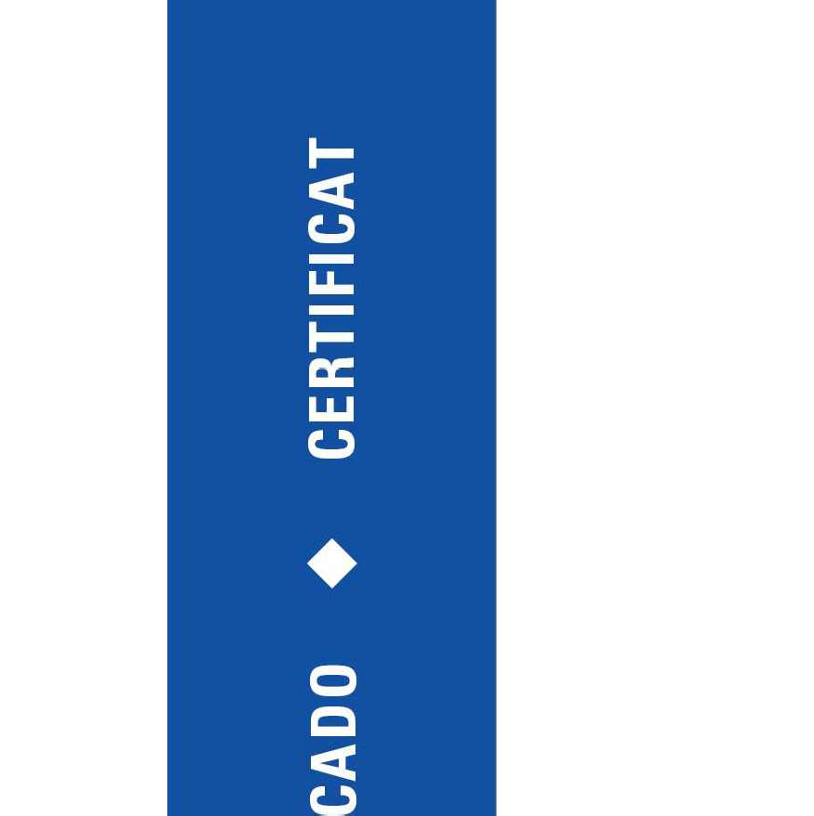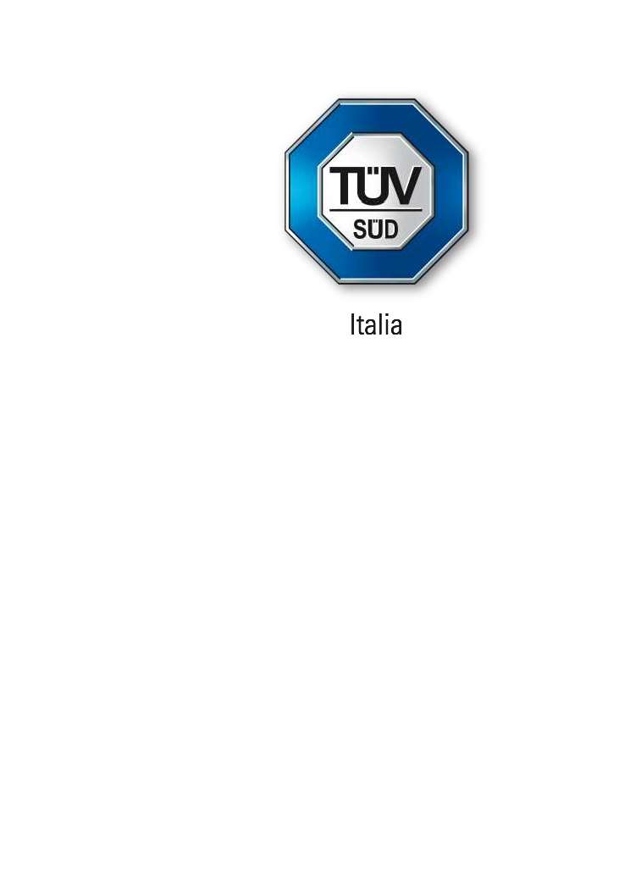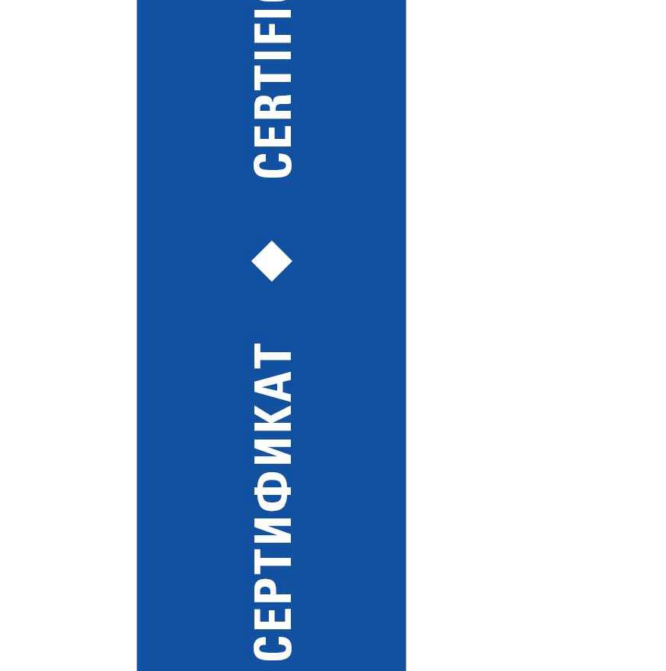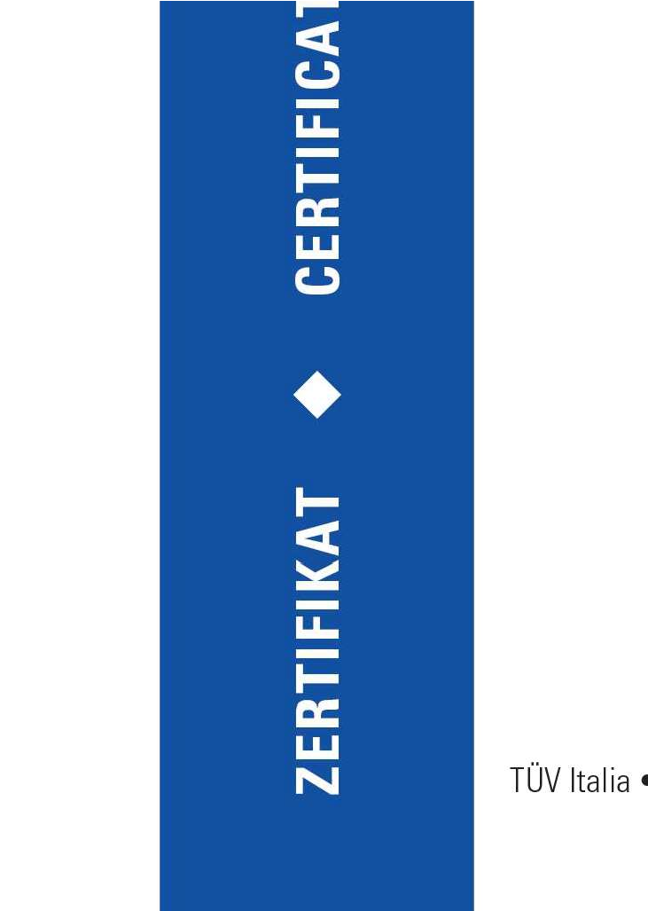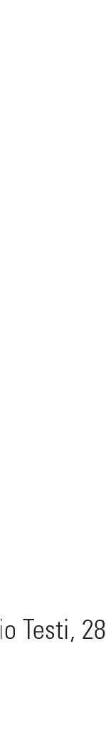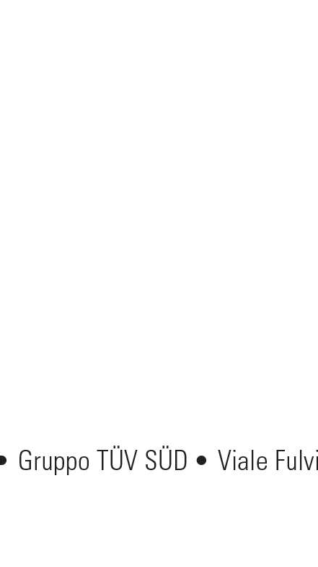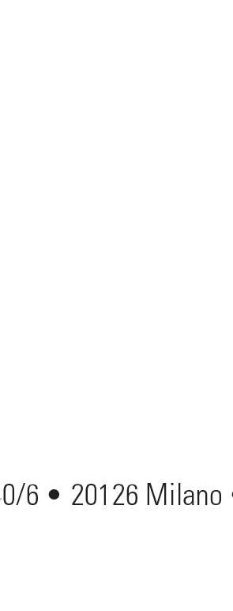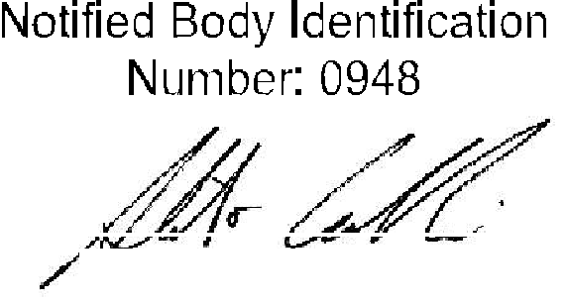

1. **Scope of application:**

Traction driven lift without separate machine room (MRL 2:1)

* 1. **Technical data Range:**

|  |  |  |  |  |  |  |  |
| --- | --- | --- | --- | --- | --- | --- | --- |
| Type: LX | 450-1275 | | | | | | |
| Rated load [kg]: | 450 | 600 | 750 | 975 | 1050 | 1200 | 1275 |
| Number of persons: | 6 | 8 | 10 | 13 | 14 | 16 | 17 |
| Max. Useful area of the car according [m²]:  to EN81-20 Art. 5.4.2 Table 6 | 1.3 | 1.6 | 1.9 | 2.35 | 2.50 | 2.8 | 2.95 |
| Min. Door width [mm]: | 700 | | | | | | |
| Min. Door height [mm]: | 2000 | | | | | | |
| Max. number of accesses to the car: | 2 | | | | | | |
| Max. mass of car [kg]: | 900 | 950 | 1050 | 1150 | 1280 | 1330 | 1450 |
| Traction machine: | PM-Gearless Traction machines | | | | | | |
| Position of the traction machine: | In the head room of the shaft | | | | | | |
| Elec. Control system: | Full selective collective according to EN 20/50 | | | | | | |
| Rated speed [m/s]: | 1.0 - 1.5 -1.75 -2.0 | | | 1.0 -1.5 1.75 2.0 2.5 | | | |
| Counterweight balance: | 45% - 50% | | | | | | |
| Min. Diameter of suspension ropes [mm]: | 10 | | | | | 10 or 12 | |
| Min. Number of suspension ropes: | 4 | | | 5 | | 6 or 5 | |
| Min. breaking force of the suspension ropes [kN] | 44 | | | | | 44 or 63.3 | |
| Min. Diameter of traction sheave [mm]: | 400 | | | | | 400 - 480 | |
| Suspension: | 2:1 | | | | | | |
| Wrapping angle [°]: | 180o | | | | | | |
| Groove type: | Semi-circular with undercut | | | | | | |
| Undercut angle [°]: | 95o | | | | | | |
| Groove angle [°]: | 30o 35o | | | | | | |
| Diameter of over speed governor rope  [mm]: | 6 - 8 | | | | | | |
| Min. breaking force of governor rope [kN]: | 17 -28 | | | | | | |
| Min. head room [mm]: | 3500 - 4500 | | | | | | |
| Min. pit depth [mm]: | 1400 - 1800 | | | | | | |
| Guide rails car ISO 7465 oiled, dry/machined: | T75 or T89 or T114 or T127 | | | | | | |
| Guide rails counterweight: | T50 or T75 or T89 | | | | | | |
| Max. distance between the guide shoes of the car [mm]: | 3800 | | | | | | |
| Max. distance between the guide shoes of the counterweight [mm]: | 3400 | | | | | | |
| Max. distance between guide brackets  [mm]: | 2500 | | | | | | |
| Max. travel height [m]: | 80 | | | 110 | | | |

AN_EATE 037_5 (1) Page 1 of 10

* + 1. **Technical data Range:**

|  |  |  |  |  |  |  |  |
| --- | --- | --- | --- | --- | --- | --- | --- |
| Type: LX | 1350 - 2040 | | | | | | |
| Rated load [kg]: | 1350 | 1425 | 1575 | 1650 | 1800 | | 2040 |
| Number of persons: | 18 | 19 | 21 | 22 | 24 | | 27 |
| Max. Useful area of the car according [m²]:  to EN81-20 Art. 5.4.2 Table 6 | 3.1 | 3.25 | 3.52 | 3.64 | 3.88 | | 4.2 |
| Min. Door width [mm]: | 800 | | | | | | |
| Min. Door height [mm]: | 2000 | | | | | | |
| Max. number of accesses to the car: | 2 | | | | | | |
| Max. mass of car [kg]: | 1480 | 1530 | 1700 | 1715 | 2000 | | 2300 |
| Traction machine: | PM-Gearless Traction machines | | | | | | |
| Position of the traction machine: | In the head room of the shaft | | | | | | |
| Elec. control system: | Full selective collective according to EN 20/50 | | | | | | |
| Rated speed [m/s]: | 1.0 - 1.5 -1.75 -2.0 -2.5 | | | | 1.0 2.0 | | 0.5-2.0 |
| Counterweight balance: | 45% - 50% | | | | | | |
| Min. Diameter of suspension ropes [mm]: | 10 or 12 | 11 or 12 | | | 12 | | |
| Min. Number of suspension ropes: | 6 or 5 | 6 or 5 | | | 6 | | |
| Min. breaking force of ropes [kN]: | 44 or 63.3 | 53.2 or 63.3 | | | 63.3 | | |
| Min. Diameter of traction sheave [mm]: | 400 or 480 | 440 or 480 | | | 480 | | |
| Suspension: | 2:1 | | | | | | |
| Wrapping angle [°]: | 180o | | | | | | |
| Groove type: | Semi-circular with undercut | | | | | | |
| Undercut angle [°]: | 95o | | | | | | |
| Groove angle [°]: | 30o 35o | | | | | | |
| Diameter of over speed governor rope [mm]: | 6 - 8 | | | | | | |
| Min. breaking force of governor rope [kN]: | 17 -28 | | | | | | |
| Min. head room [mm]: | 3600 - 5000 | | | | | | |
| Min. pit depth [mm]: | 1600 - 2000 | | | | | | |
| Guide rails car ISO 7465 oiled, dry/machined: | T75-3 or T89 or T114 or T127 | | | | | | |
| Guide rails counterweight: | T50 or T75 or T89 | | | | | | |
| Max. distance between the guide shoes of the car [mm]: | 3800 | | | | | | |
| Max. distance between the guide shoes of the counterweight [mm]: | 3400 | | | | | | |
| Max. distance between guide brackets  [mm]: | 2500 | | | | | | |
| Max. travel height [m]: | 110 | | | | | 80 | |

AN_EATE 037_5 (1) Page 2 of 10